PlayStoreAppReviewAnalysis

Presentedby-Hritik Saini , Arpit Dargan

|  |  |
| --- | --- |
| Category | Categoryunder whichit falls |
| Rating | Application’sratingonplaystore |
| Reviews | Number ofreviewsofthe app |
| Size | Sizeof theapp |
| Installs | NumberofInstallationoftheapp |
| Type | Whetherthe appisfree or paid |
| Price | Priceoftheappifit’sapaidapp(0if it’s afreeapp) |
| ContentRating | Appropriatetargetaudienceoftheapp |
| Genres | Genresunderwhichthe appfalls |
| LastUpdated | DatewhentheAppwaslastupdated |
| CurrentVersion | Current version ofthe App |
| AndroidVersion | Minimum android versionrequiredtosupportthe App. |

# ABSTRACT

Google play store is simply entertainment at ourfingertips. It’s an official app store and a digitalmedia store having enormous things to offer likebooks, movies, programs and music. Applicationsare either free or paid. Our team has worked onplaystoredata.Thisdatasetcontains13featuresand10840 observations. This information can be usedforpredictingkeyfactorsresponsibleforappengagement&successstory.

## INTRODUCTION

Play store is not just an app store, it’s a platformoffering various digital content to its consumers.TheGooglePlayStoreishometoandroidapplications,music,movies,books,gamesandtelevision programs. 81% of the apps are free ofcost which has led to immense popularity of thisplatform. As per google survey report 3000+ appsare being added every other day. The Google PlayStore contains applications for the Android systemonly. This document reveals the dynamics of thePlay Store app and gives actionable insights for thedeveloperstoworkonandruletheAndroidmarket.

## INTEGRALMETHODOLOGY:

First,weinvestigatedsomebasicinformationofourdataset. On doing so we found out that our dataneeded some cleaning, some values were missing,andsomedatatypeswereincorrect.Westartedwithdatacleaningandcorrectingthedatatypes,followed by data visualisation. We removed someunnecessaryfeaturesandmadeitreadyforanalysisusingdifferentplots.

## DATASETDESCRIPTION:

Thisdatasethas13featuresand10840observations

|  |  |
| --- | --- |
| App | Nameof the App |

## BREAKDOWNOFDATASETS

Beforeproceedingtodatavisualisation,weneedtoperformthe followingsteps:

1. Importingrequiredpackagesforfutureanalysis.
2. MountingdriveandreadingdatafilesfromGoogledrive.
3. Removingfuturewarningsinseabornplots.
4. Viewingall datainformation.
5. Droppingduplicate.
6. Removingspecialcharacters
7. Checkinguniquevalues,nullcountanddatatypesof each column.
8. Segregationofnumericalandcategoricaldata.

## EXAMININGNULL/ MISSINGVALUES

Some values in our dataset are null or missing.These values affect the accuracy and performanceof the models that predict the outcome, so theseneedtobehandled.Whileanalysingourdatasetthefirst thing we will do is to examine the null ormissingvaluesinourdataset.Thismakesourresultaccurate.Missing values are more in Size & Ratingcolumns as can be seen by plotting graphs. Henceseveralmethods areusedtoremovethese values.

## DATACLEANING

Datacleaningistheforemoststepinanydatascienceproject.Cleanerthedata,betteraretheresults.Astheproverbgoesbysaying“MoreDatabeatscleveralgorithm,butbetterdatabeatsmoreData”–PeterNorvig.Tobeginwithourdatacleaning,firstweremovetheduplicatevalues.Thenwe remove unnecessary characters in our dataset.Afterdoingsowefindtheuniquevaluesofeachcolumnandmakethenecessarychangesineachcolumnlikeconvertingdatatypes,removingthenulland‘nan’values.Lastly,wehavedoneexploratorydata analysis ofour dataset.

**DATAVISUALIZATION**

# Observation1:

From this barplot graph analysis it tells that category social has the highest and events has the lowest value.

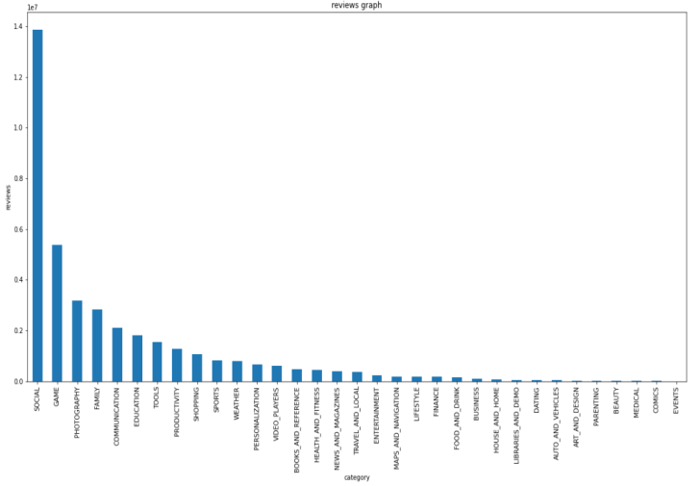

# Observation2:

Weplotted agraph oftop categories on playstore

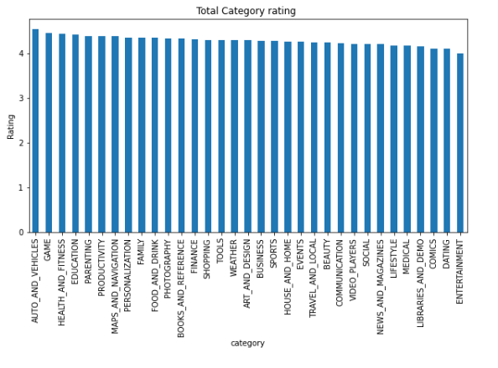

# Observation3:

Weplotted agraph oftop five genres.

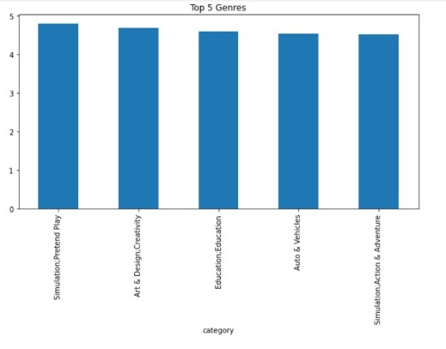

# Observation4:

We plotted a graph on installation vs ratings.

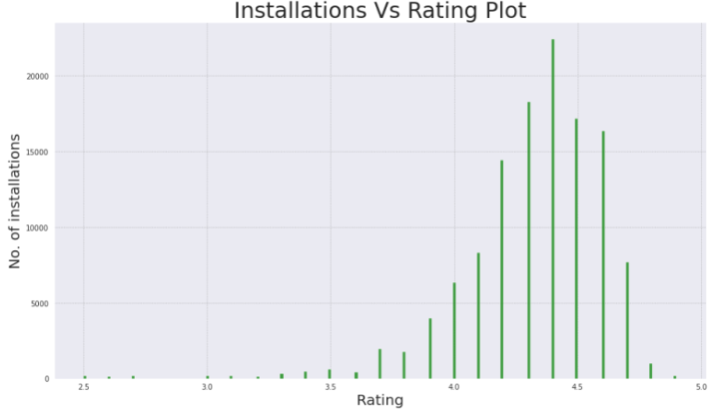

**observation5:**

Weplottedagraph on installation per

category

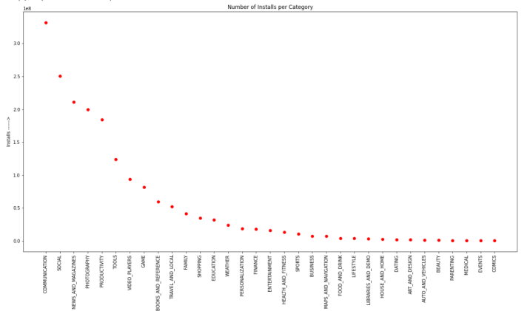

# Observation6:

We plotted a graph on sentiment polarity

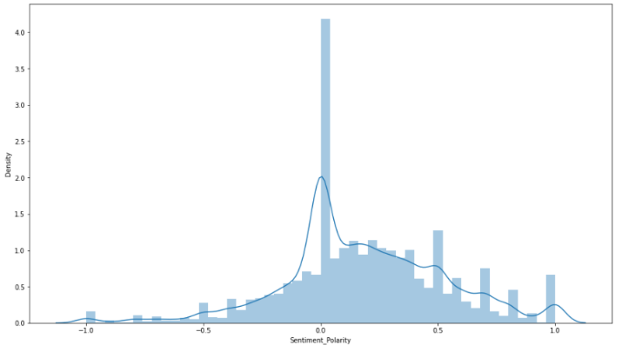

# Observation7:

We plotted a pie chart of top five category.

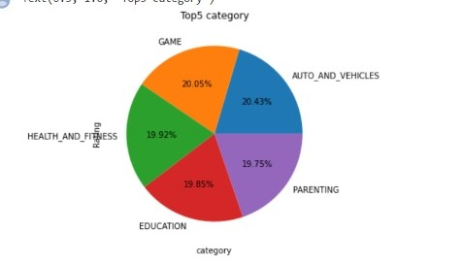

**Observation 7:**

Percentage of paid and free apps

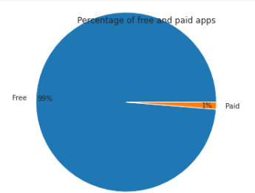

Advantages of visualisation

Visualiseddataisprocessedfasterandeasier.

* Better insights of the data are drawnwhichmaybe missedintraditionalreports
* Helps us visualise trends whichimproveperformance

## CONCLUSIONANDFUTUREWORK

The app developers can predict the outcome ofthe developed apps. Better insights are drawnfrom this visualisation. Apps which need to beimprovedcanbeworkeduponbythedevelopers.Thedatasetcontainsimmensepossibilitiestoimprovebusinessvaluesandhaveapositiveimpact.

Wecouldaddasystemthatwouldcreateapplication on its own by using the data set andcreating the best user interface by highly ratedapps.

## ACKNOWLEDGEMENT

This project is presented by-Sarthak Arora, JayNandasana,ArshiWani,PranjaliTete,MadhaviMali.

Our sincere efforts have made us to accomplishthetaskofcompletingthisproject.Weareextremelygratefultoourinstructorsandmentors who have helped us to grow in thisfield.Wewouldliketoexpressoursinceregratitudetothecelebratedauthorswhosephenomenalworkhasbeenconsultedandreferred in our project work. We also wish toconveyourappreciationtoourpeerswhoprovided encouragement and timely support inthehourofneed.Thisprojecthelpedusimproveourskillsandenhancedourknowledge.

## REFERENCES

<https://seaborn.pydata.org/tutorial/color_palettes.html>[https://www.python-graph-gallery.com/196select-one-color-with-matplotlib](https://www.python-graph-gallery.com/196-select-one-color-with-matplotlib)[https://www.analyticsvidhya.com/blog/2021/05/10-colab-tips-and-hacks-for-efficient-use-ofit/](https://www.analyticsvidhya.com/blog/2021/05/10-colab-tips-and-hacks-for-efficient-use-of-it/)